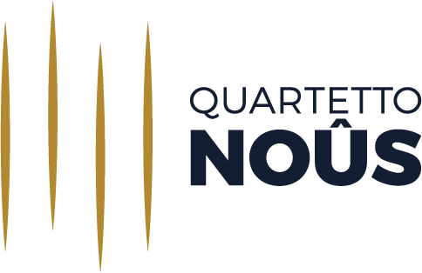

PROGRAMS 2020/2021

1
L. van Beethoven – String Quartet No.13 in B-flat major Op.130
A. Berg – Lyrische Suite

2
L. van Beethoven – String Quartet No.15 in A minor Op.132
F. Mendelssohn – String Quartet in A minor Op.13 No.2

3
W. A. Mozart – String Quartet No.1 in G major K 80
F. J. Haydn – String Quartet in F minor Op.20 No.5
B.Bartók – String Quartet in A minor No.1 Op.7

4
L. van Beethoven – String Quartet No.7 in F major Op.59 No.1
D. Šostakovič – String Quartet No.3 in F major Op.73

5
G. Puccini – ‘Crisantemi’, Elegy for String Quartet
L. Boccherini – String Quartet in D major op.8 n.1, G165
G. Verdi – String Quartet in E minor
O. Respighi – String Quartet in D minor P.91, ‘Ernst ist das Leben heiter ist die Kunst’

